# **School of Computer Engineering & Technology**

A Mini Project Report

*on*

“An LSTM Approach for SMS Classification using Recurrent Neural Network”

*by*

Arjun Yachwad (B194032)

Prashant Walunj (B194158)

Pranav Dighe (B194152)

Tushar potale (B194143)

*of*

**B.Tech**

**Academic Year: 2019-2020**

|  |  |
| --- | --- |
|  |  |
|  |  |

**Introduction**

In recent years, the use of mobile phones and smart systems has increasingly developed, and Short Message Service (SMS) has become one of the most important means of communication; so that 97% of cell phone users use this service. Unwanted short messages (known as spams) are transferred on the communication channel such as SMS, perform great advertising, but as a disturbing factor for users. In 2012, more than 6 billion messages were transferred on mobile phones in USA. According to a study in 2011, 3.5 billion people or 80% of active users in the world use SMS of mobile phone as a means of communication.

According to a study in 2011, 3.5 billion people or 80% of active users in the world use SMS of mobile phone as a means of communication. Of this large number of short messages, many are unwanted SMS messages produced for the following reasons.

* Sending SMS is low cost and many mobile operators offer SMS packages with very low price.
* Since users interact more with mobile phones compared to computers, they have more confidence in SMS, and it is very convenient to send confidential information [3].

**Problem Statement**

Short Message Service (SMS) is one of the well-known communication services in which a message sends electronically. The lessening in the cost of SMS benefits by telecom organizations has prompted the expanded utilization of SMS. This ascent pulled in assailants, which have brought about SMS Spam problem.

Spam messages include advertisements, free services, promotions, awards, etc. People are using the ubiquity of mobile phone devices is expanding day by day as they give a vast variety of services by reducing the cost of services. Short Message Service (SMS) is one of the broadly utilized communication service. In any case, this has prompted an expansion in mobile phones attacks like SMS Spam. In this problem, preliminary results are mentioned or explained herein based on Singapore based publically available datasets. This problem is further expanded using multiple background datasets.

|  |  |
| --- | --- |
|  |  |
|  |  |
|  |  |

**III. THE PROPOSED METHOD**

The ability of the brain to process huge volumes of information in a short time, the use of parallel structure in data analysis, and the remarkable ability of the human brain in learning various issues are special features. Therefore, simulation is always been tempting, and deep neural networks have been created for this purpose. Among all machine learning algorithms, Deep Recurrent Neural Networks (DRNNs) work on data sequence [15]. Sequential data are data whose current values depend on previous values [16]. Among such data, the following can be noted.

* Frames (samples) of speech signal x Continuous Frames (images) of Video
* Climatic condition
* The stock price of a company / industry
* The sequences generated by the grammar
* Words within a text RNNs are very powerful because of combining the following features:

Distributed hidden layers, which allow them to save a lot of information about previous layers.

* Non-linear dynamics, which allows such networks to update hidden layers in a complex way.
* RNNs have the potential to provide implementation and enforcement for small and parallel programs, and thus have a great interaction for producing more complicated results.
* With the number of neurons at hand and enough time, RNNs have the ability to do any calculations performed by a computer.

**Recurrent Neural Network (RNN):**

A RNN contains an input layer, hidden layer, and output layer, as well as feedback connection weights, activation functions, and interconnection weights. In this study, the proposed RNN is designed by the combination of the locally recurrent and globally feed forward structure. The dynamic properties are achieved by utilizing the internal feedbacks as shown in Figure.

For a clear understanding of the computational model for the proposed RNN through the proposed structure, the mathematical function of each node is described as follows: Figure. The structure of recurrent neural network Input layer: There are M nodes, which represent the input variables in this layer. The output values of each node can be described as Equation (1): where ui(t) is the ith output value at time t, i = 1, 2, . . ., M, and the input vector is x(t) = [x1(t), x2(t), . . ., xM(t)]. Hidden layer: each node in hidden layer connects with the input nodes and output node of RNN. The output of each hidden node.

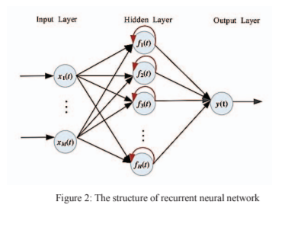

**Preprocessing and Feature Extraction:**

First, short texts are collected with custom-made crawlers for different social media. Then, preprocessing tasks are needed to cleanup post contents. For example, URL links, hashtags, and emoticons are filtered. Also, stopword removal is performed to focus on content words. For Chinese posts, we used Jieba for word segmentation. Then, we extract metadata such as poster ID, posting time, and the number of retweets and likes. These will be used as additional features for classification.

**Sentiment Classification:**

After sentiment classification model is trained using LSTM, all posts in test set are preprocessed with the same procedure as the training set, and represented using the same word embedding model. Then, for testing step, the same processes of LSTM in Fig. 2 are followed, except for the weights update. The output of LSTM model will then be evaluated with the labels of each post in test data in the experiments.

**Details of Dataset**

The SMS Spam Collection is a set of SMS tagged messages that have been collected for SMS Spam research. It contains one set of SMS messages in English of 5,574 messages, tagged acording being ham (legitimate) or spam.

The files contain one message per line. Each line is composed by two columns: v1 contains the label (ham or spam) and v2 contains the raw text.

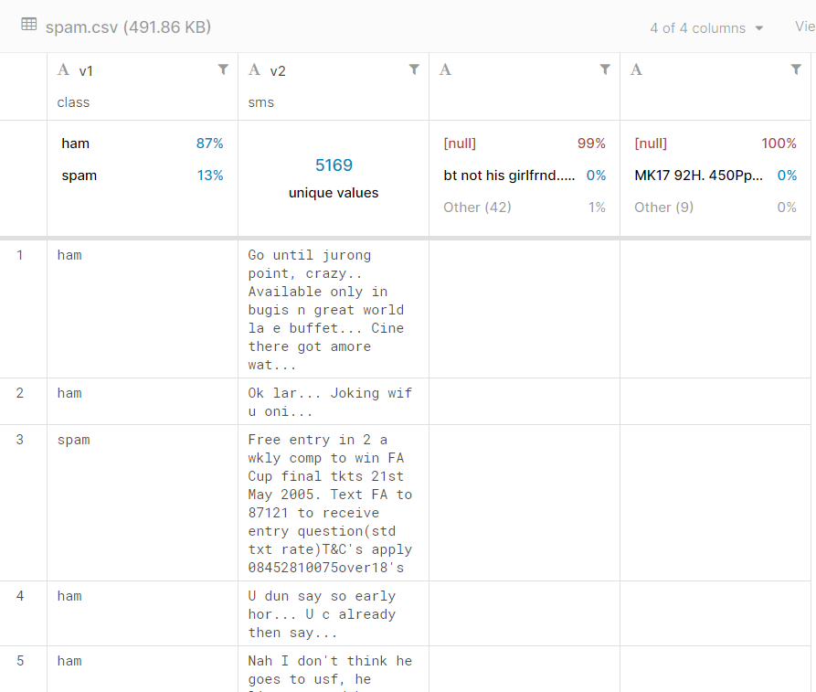

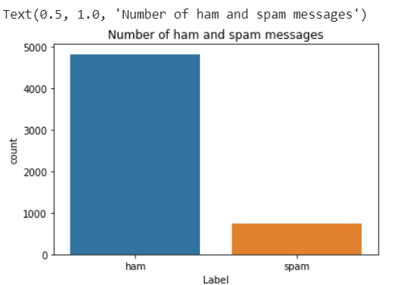

**Results & Analysis**

classification method is provided for detecting unwanted and normal messages. So far, in the previous studies, SVM or Bayesian methods is used. The proposed method RNNs is used. Test results on standard datasets UCI SMS spam showed the efficiency of the proposed method. In the proposed method, after 10 initial epochs, when a steady state is observed, a high accuracy of 98% is obtained .

**Conclusion**

In this paper, we have proposed a sentiment classification approach based on LSTM for short texts in social media. Using word embeddings such as Word2Vec model, it’s feasible to train the contextual semantics of words in short texts. Also, deep learning methods such as LSTM show better performance of sentiment classification when there are more amounts of training data. For special community behaviors, further experiments using “community”-specific sentiment lexicon and larger data sizes are needed in future.

**References**

[1] Y. Kim, “Convolutional Neural Networks for Sentence Classification,” Proceedings of the 2014 Conference on Empirical Methods in Natural Language Processing (EMNLP 2014), pp. 1746–1751, 2014.

[2] J. L. Elman, “Finding Structure in Time,” Cognitive Science, Vol. 14, No.2, pp. 179-211, 1990.

[3] T. Mikolov, K. Chen, G. Corrado, and J. Dean, “Efficient Estimation of Word Representations in Vector Space,” Proceedings of the International Conference on Learning Representations 2013 Workshop.

[4] S. Hochreiter and J. Schmidhuber, “Long Short-Term Memory,” Journal of Neural Computation, Vol. 9 No. 8, pp. 1735-1780, 1997.

[5] G. B. Huang, Q. Y. Zhu, and C. K. Siew, "Extreme Learning Machine: Theory and Applications," Neurocomputing, 70 (1): 489–501, 2006.